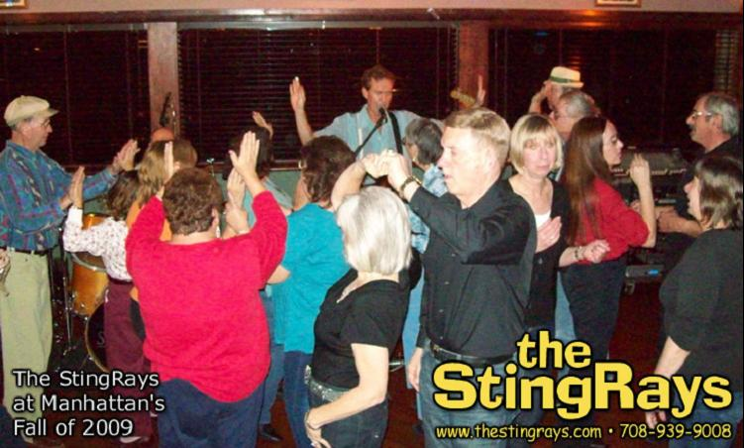
April 2010  S M T W T F S  1 2 3  4 5 6 7 8 9 10  11 12 13 14 15 16 17  18 19 20 21 22 23 24  25 26 27 28 29 30 | May 2010 |  |  |  |  | June 2010  S M T W T F S  1 2 3 4 5  6 7 8 9 10 11 12  13 14 15 16 17 18 19  20 21 22 23 24 25 26  27 28 29 30
Sunday | Monday | Tuesday | Wednesday | Thursday | Friday | Saturday
 |  |  |  |  |  | 1
2 | 3 | 4 | 5 | 6 | 7 | 8  Ki's, 9pm  705 North Avenue  Glendale Heights, IL
9 | 10 | 11 | 12 | 13 | 14  Manhattan's, 9:30  300 S Schmale Rd  Carol Stream, IL | 15
16  Villa Park Concert  Ruggard Gazebo  Ardmore & Park  time soon | 17 | 18 | 19 | 20 | 21 | 22
23  30 | 24  31 | 25 | 26 | 27 | 28 | 29

