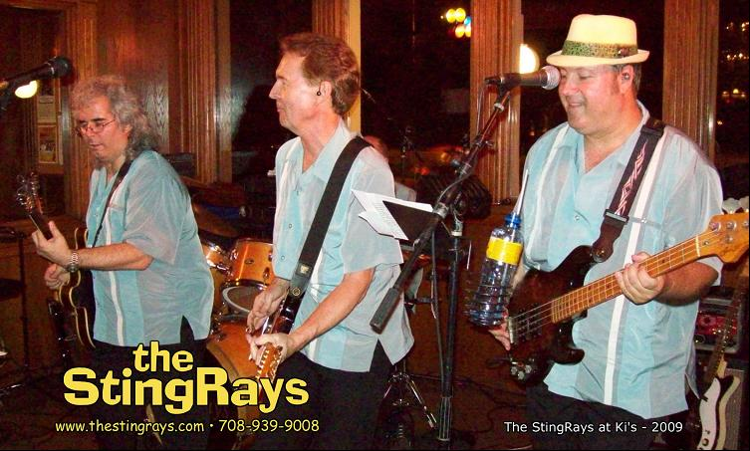
February 2010  S M T W T F S  1 2 3 4 5 6  7 8 9 10 11 12 13  14 15 16 17 18 19 20  21 22 23 24 25 26 27  28 | March 2010 |  |  |  |  | April 2010  S M T W T F S  1 2 3  4 5 6 7 8 9 10  11 12 13 14 15 16 17  18 19 20 21 22 23 24  25 26 27 28 29 30
Sunday | Monday | Tuesday | Wednesday | Thursday | Friday | Saturday
 | 1 | 2 | 3 | 4 | 5 | 6
7 | 8 | 9 | 10 | 11 | 12 | 13
14 | 15 | 16 | 17 | 18 | 19  Manhattans, 9:30pm  300 S. Schmale Rd  Carol Stream, IL | 20
21 | 22 | 23 | 24 | 25 | 26 | 27  Ki's, 9:00pm  705 North Avenue  Glendale Heights, IL
28 | 29 | 30 | 31

