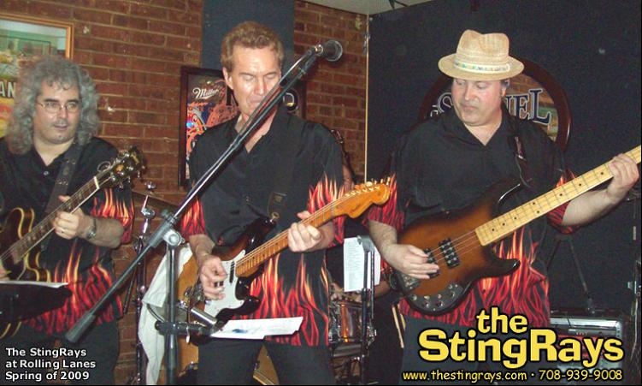
March 2010  S M T W T F S  1 2 3 4 5 6  7 8 9 10 11 12 13  14 15 16 17 18 19 20  21 22 23 24 25 26 27  28 29 30 31 | April 2010 |  |  |  |  | May 2010  S M T W T F S  1  2 3 4 5 6 7 8  9 10 11 12 13 14 15  16 17 18 19 20 21 22  23 24 25 26 27 28 29  30 31
Sunday | Monday | Tuesday | Wednesday | Thursday | Friday | Saturday
 |  |  |  | 1 | 2 | 3
4 | 5 | 6 | 7 | 8 | 9  Rolling Lanes 9:30  6301 Joliet Rd.  Countryside, IL | 10
11 | 12 | 13 | 14 | 15 | 16 | 17  Manhattan's, 9:30  300 S Schmale Rd  Carol Stream, IL
18 | 19 | 20 | 21 | 22 | 23 | 24
25 | 26 | 27 | 28 | 29 | 30

